EXPT NO: 3 | IMPLEMENTATION OF CONVOLUTIONAL NEURAL NETWORKS (CNNs) FOR IMAGE CLASSIFICATION
DATE:

PRE-LAB QUESTIONS (PROVIDE BRIEF ANSWERS TO THE FOLLOWING QUESTIONS)
- What is a Convolutional Neural Network (CNN)?

A Convolutional Neural Network (CNN) is a deep learning model specially designed for processing image data. It automatically extracts important features such as edges, textures, and shapes to classify images accurately.

- What are the functions of convolution and pooling layers in a CNN?
Convolution Layer:
Extracts important features from images.
Applies filters to detect patterns like edges and textures.
Pooling Layer:
Reduces the size of feature maps.
Decreases computation and helps prevent overfitting.
- Differentiate between image classification and object detection.
Image Classification | Object Detection
Predicts the class of the entire image. | Identifies and locates multiple objects in an image.
Produces one label. | Produces labels and bounding boxes.
Example: "This is a cat." | Example: Detects cat, dog, and person with locations.

- Why is image preprocessing important before training a CNN model?
Image preprocessing:
  - Improves image quality.
  - Resizes images to a fixed size.
  - Normalizes pixel values.
  - Reduces noise.
  - Helps the model train faster and achieve better accuracy.

- What are the advantages of using benchmark datasets such as CIFAR-10 or Kaggle image datasets.
• High-quality labeled images.
• Standard datasets for fair comparison.
• Large amount of training data.
• Improve model reliability.
• Widely used for research and learning.

AIM
To design, implement, and evaluate a Convolutional Neural Network (CNN) for image classification using a benchmark image dataset.

SOFTWARE REQUIREMENTS
- Python
- TensorFlow/Keras or PyTorch
- Google Colab
- Matplotlib
- Kaggle Dataset (e.g., CIFAR-10, Cats vs Dogs, Intel Image Classification)

OBJECTIVES
Students will be able to:
- Understand the architecture of Convolutional Neural Networks.
- Implement a CNN model for image classification.
- Train and evaluate a CNN using a real-world image dataset.
- Visualize training and validation performance.
- Analyze the effectiveness of CNNs for image recognition tasks.

PROCEDURE
PART A: DATASET PREPARATION
- Perform the following tasks:
- Download an image dataset from Kaggle or use CIFAR-10.
- Load the dataset.
- Preprocess images by resizing and normalization.
- Split the dataset into training, validation, and testing sets.

PART B: CNN MODEL IMPLEMENTATION
Build a CNN model consisting of:
- Convolution layers
- ReLU activation
- Max Pooling layers
- Fully Connected layers
- Softmax output layer

Compile the model using:
- Appropriate optimizer
- Cross-entropy loss function

PART C: MODEL TRAINING AND EVALUATION
Train the CNN model.
Record:
- Training accuracy
- Validation accuracy
- Training loss
- Validation loss
- Testing accuracy
Plot:
- Accuracy vs Epoch
- Loss vs Epoch

PART D: PERFORMANCE ANALYSIS
Analyze:
- Classification accuracy
- Confusion Matrix
- Sample predictions
- Misclassified images
Discuss the strengths and limitations of CNNs for image classification.

CODE AND OUTPUT SCREENSHOT
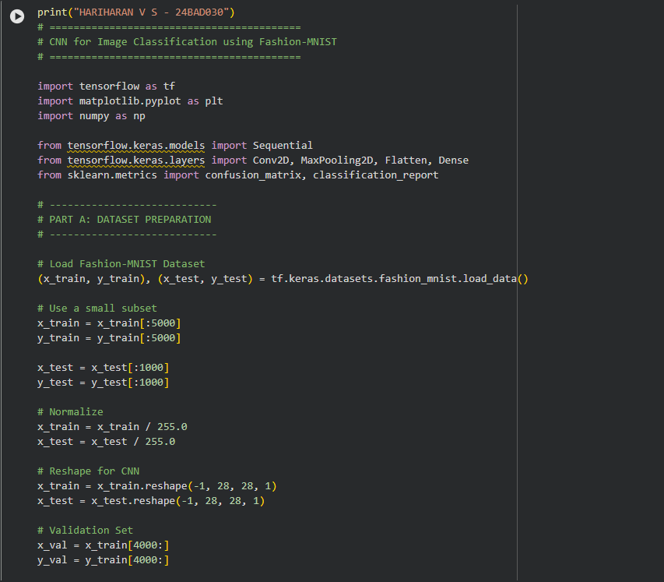
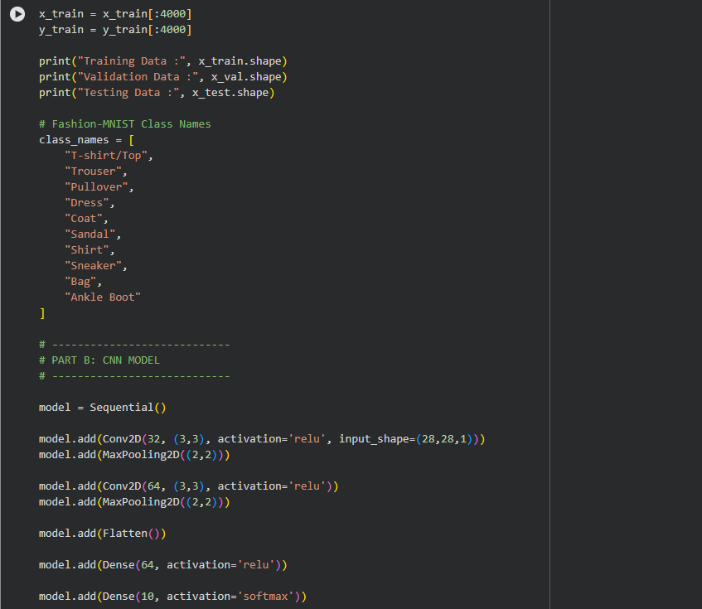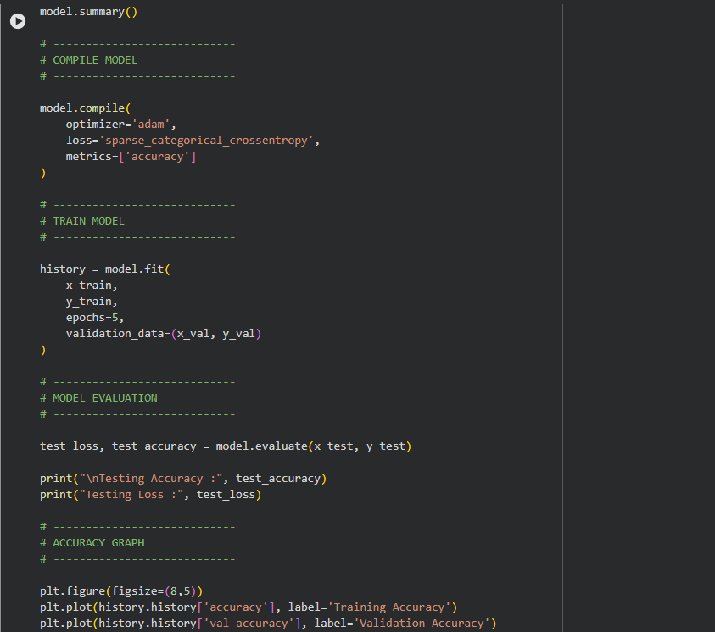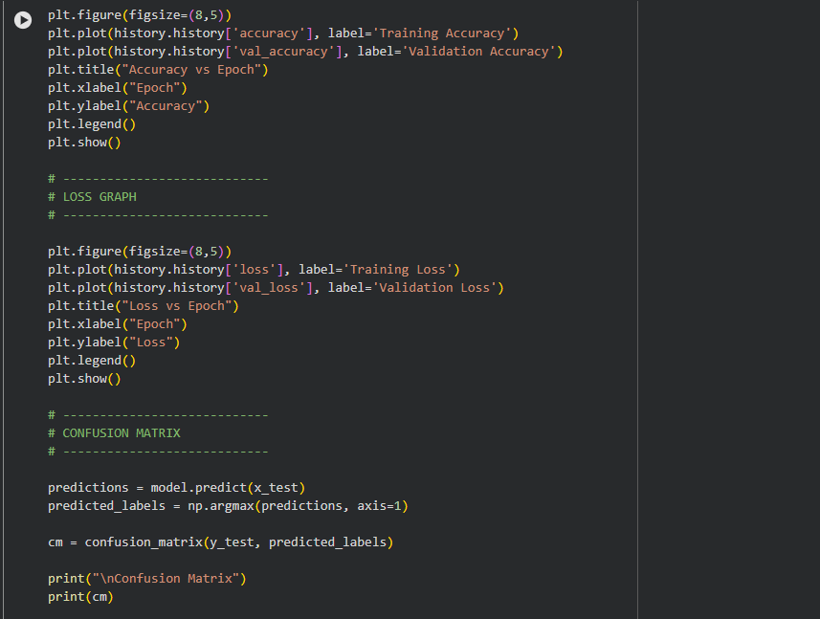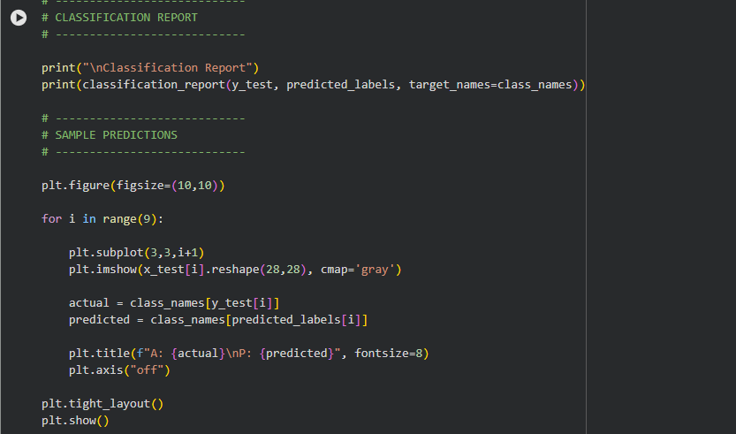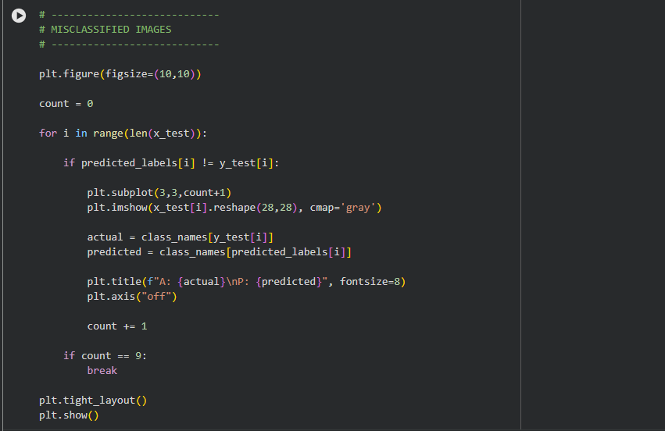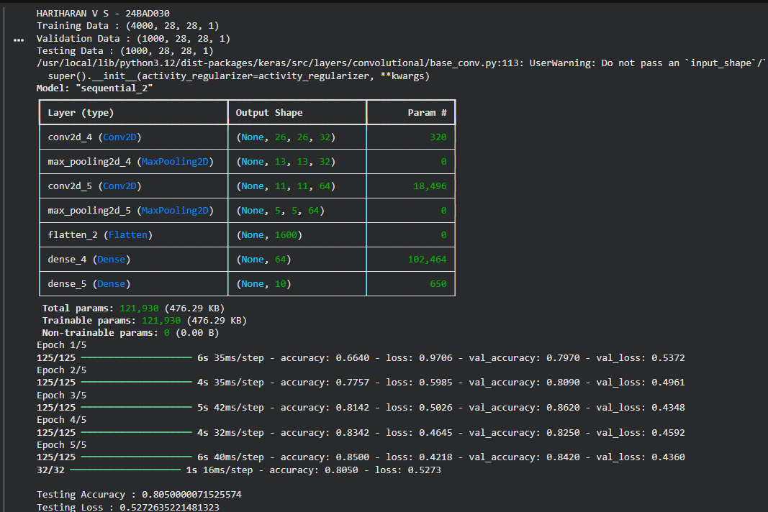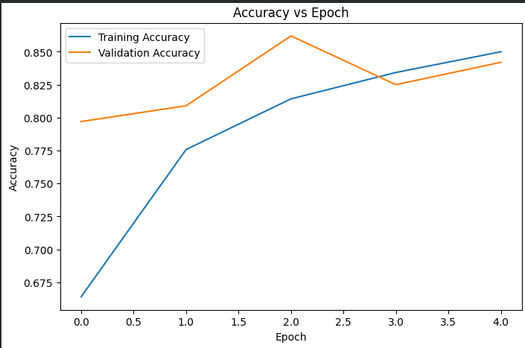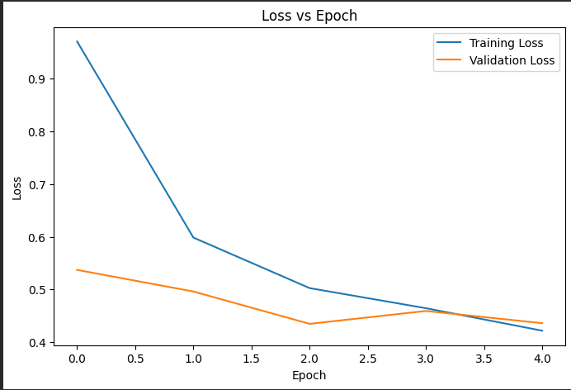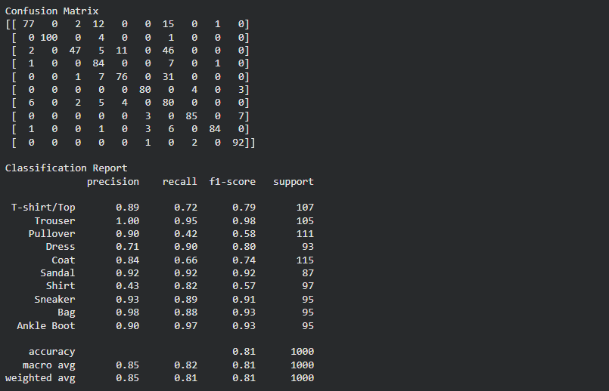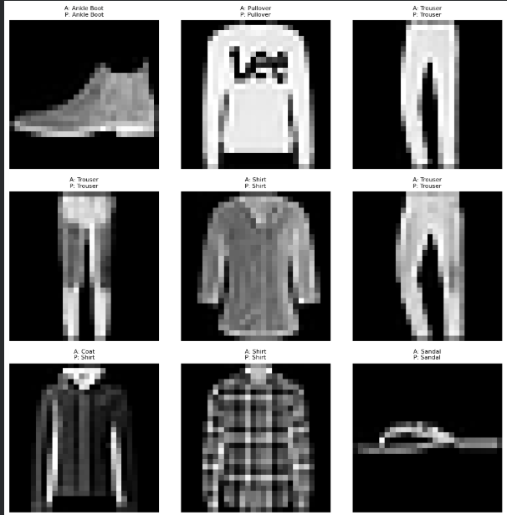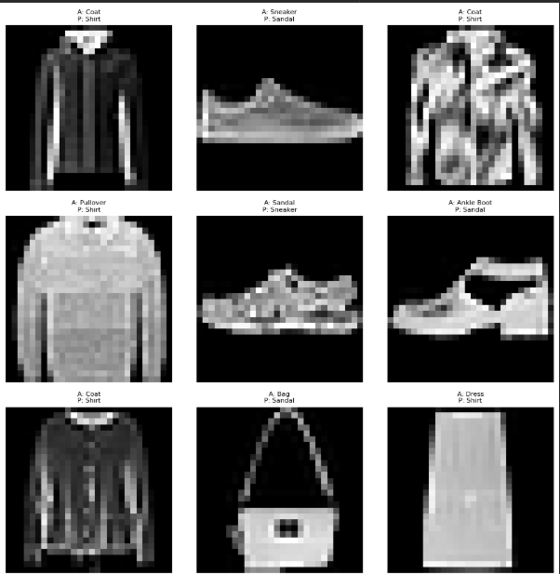

EXPECTED OUTCOME
Students will gain practical experience in designing, training, and evaluating CNN models for image classification and understand how CNN architecture influences classification performance.

POST-LAB QUESTIONS (PROVIDE BRIEF ANSWERS TO THE FOLLOWING QUESTIONS)
- Why are convolution layers more effective than fully connected layers for image processing?
Convolution layers detect local image features using shared filters, requiring fewer parameters and preserving spatial information. Fully connected layers ignore spatial relationships and require many more parameters.
- How does Max Pooling improve CNN performance?
Max Pooling:
- Reduces feature map size.
- Decreases computation time.
- Prevents overfitting.
- Makes the model more robust to small image changes.
- Which hyperparameters significantly affected your CNN model performance?
Important hyperparameters include:
- Learning rate
- Batch size
- Number of epochs
- Number of convolution filters
- Kernel size
- Optimizer (Adam/SGD)
- What challenges did you encounter while training the CNN model?
Possible challenges:
- Overfitting
- Long training time
- Limited dataset size
- Incorrect hyperparameter selection
- Hardware limitations

- Suggest two improvements that can increase the classification accuracy of your CNN.
• Apply data augmentation (rotation, flipping, zooming).
• Use a deeper CNN architecture with Batch Normalization and Dropout or apply transfer learning using pretrained models.

ASSESSMENT
Description | Max Marks | Marks Awarded
Pre Lab Exercise | 5
In Lab Exercise | 10
Post Lab Exercise | 5
Viva | 10
Total | 30
Faculty Signature

